FIND THE NUMBER OF VOWELS

AIM: To implement a prolog program to Find the Number of Vowels.

OBJECTIVES:
- To write a Prolog program that counts the number of vowels present in a given word or list of characters.

ALGORITHM:
- Take a list of characters as input.
- Check the first character.
- If it is a vowel, increment the count.
- Otherwise, continue without incrementing.
- Repeat until the list is empty.
- Display the total number of vowels.

SYSTEM-ARCHITECTURE:
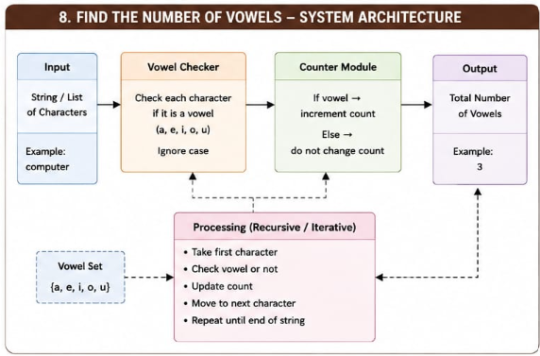

PROGRAM:
% Count Number of Vowels

vowel(a).
vowel(e).
vowel(i).
vowel(o).
vowel(u).

count_vowels([], 0).

count_vowels([H|T], Count) :-
vowel(H),
count_vowels(T, Count1),
Count is Count1 + 1.

count_vowels([H|T], Count) :-
\+ vowel(H),
count_vowels(T, Count).

OUTPUT:
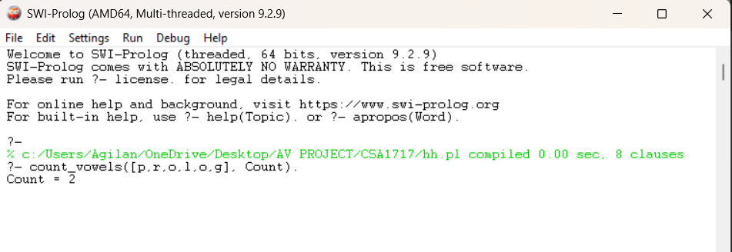

RESULT: Thus the Find the Number of Vowels is implemented successfully using Prolong program.

